OVERTIME ATHLETICS – “Set Ups”

**Directions: It is very important to begin to set up the necessary business and administrative components for operating the Overtime Athletics Franchise System. Please review the below and move forward with any actions required to achieve the desired outcome of having these in place**

Office (and Mobile System)

Where is your office/desk?

*Answer:*

Have you identified meeting locations in your Staff Recruitment Spreadsheet?

*Answer:*

What is your equipment storage strategy?

*Answer:*

**Office and Operational Needs Confirmation List:**

|  |  |  |  |
| --- | --- | --- | --- |
| Business Cards |  | Printer Paper |  |
|  |  | Envelopes |  |
| Printer/Copier |  | Pads |  |
| Ink |  | Folders |  |
|  |  | Files |  |
| White Board |  | Paperclips |  |
| Clip Board |  | Tape |  |
|  |  | Pens |  |
| Stapler |  | Highlighter |  |
| Scissors |  | Dry Erase Markers |  |
| Hole Puncher |  | Staples |  |
|  |  | Thumbtacks |  |
| File Storage |  | Rubber Bands |  |
| Mobile "Bins" Carrier |  | Post Its |  |
|  |  |  |  |
| Address Stamp |  |  |  |
| Stamps |  |  |  |

Outlook / Email

**Director Inbox Organization**

Inbox “clutter” leads to missing deadlines, overlooking action items, and general disorganization. We have created a set of rules to manage emails and to archive exchanges in order to manage from a successful platform.

Rules:

1. The emails in your inbox should act as a “to do” list.
2. If there are emails in your inbox that you have already answered and dealt with, they should not be in your inbox (**They should be filed to the pertinent folder or deleted**)

Here are 4 examples:

Example 1:  Email from HQ outlining a task/assignment. This email should remain in your inbox until the action has been completed. Once you have completed the project, you can delete the email or file it away in a folder.

Example 2:  Email from ASP Coordinator. For example, if a coordinator emails you about a new dismissal procedure – make a note of it on the BOARD to review email about dismissal.  Leave that email in the inbox until the morning of that class; once you have discussed the new dismissal with the instructors during their call in, file away the email in that particular school folder.

Example 3:  Conference Call Agenda. That email should remain in your inbox until the meeting.  Once the meeting is complete, you can file it away… (Unless of course there are things on the agenda that you need to complete)

Example 4:  Email from School. For example, if a representative of a school sends an email with program feedback, share that with the instructors and Director, and then file away the email in that particular school folder.

Set Up Outlook on Mobile Phone: Completed -

Send TEST Email from OTA Account: Completed -

Create the Following Folders in Outlook: Completed -

* Schools
* Summer Session
* Staff
* Insurance
* Legal
* Accounting
* Whelan
* Horich

ShareFile

**Cloud Review**

OTA’s cloud is a [file hosting service](http://en.wikipedia.org/wiki/File_hosting_service) that offers [cloud storage](http://en.wikipedia.org/wiki/Cloud_storage), [file synchronization](http://en.wikipedia.org/wiki/File_synchronization), and [client](http://en.wikipedia.org/wiki/Client_(computing)) software. It allows users to create a special folder on each of their computers, which then synchronizes so that it appears to be the same folder (with the same contents) regardless of the computer it is viewed on. Files placed in this folder are also accessible through a website and mobile phone applications.

Primary Folders:

* *Operations*
* *Programming Territory*
* *Curriculum*
* *Sales and Marketing*

A summary of each FOLDER:

* *Operations* – Where you will find all of our universal tools, items and documents needed for running programs as a PD. Everything from curriculum to IHT to manuals and continuous training can be found in here. Template Emails are also located here.
* *Programming Territory* – Where most of the PD’s day to day activities take place, each area has their own space and operates within it updating and changing the spreadsheets we use to keep track of programs and employees.
* *Curriculum* – Where OTA keeps the master copy of all programming and special activity curriculum to include table of contents, warm up games, skills, drills, and sample programming day cards.
* *Sales and Marketing* – Where you will finds marketing and sales materials and tools

**Operations Folder** is organized the following way:

* + You may not alter, move, add, or subtract ANY document in the Operations Folder without approval from HQ. (notice the numbers are placed before heading so that they will be listed in Dropbox in that order)

1. Operation Folder

* 1 IHT System
* 2 Instructor Folder
* 3 Cont. Training
* 4 Equipment
* 6 ASP Support
* 7 Director Management
* 8 Program Management
* 9 Staff Management
* 10 Summer Session
* 11 Summer Camp Training
* 12 Birthday Party Division

**Programming Territories Folder** should be organized the following way:

* + Programming Territory folders should have the following Folders listed in the following order (notice the numbers are placed before heading so that they will be listed in Dropbox in that order)

1. Programming Territory
   * + - 1 Instructors
       - 2 Recruitment
       - 3 Payroll
       - 4 Schools
       - 5 Summer Session
       - 6 Other Camps
       - 7 Other

Guidelines for Programming Territory Organization:

**Instructors** – should contain

* Folder - OLD
* Folder - Clearance Reports (Background Checks)
* Folder - Staff Cont. Training
* Folder - Instructor Field Evaluations
* Folder - Program Progress Reports
* Folder - Staff Meeting Details
* Document - Current Instructor Info Sheet

**Recruitment** – should contain

* Folder - Applicants
* Folder - Job Announcements
* Document - Instructor Recruitment Options
* Document -Target Instructor Recruitment Spreadsheet

**Payroll –** should contain

* Folder - OLD
* Document – Current Payroll Spreadsheet

**Schools –** should contain

* Folder for each Partner (school)
  + rosters should be in these folders, not in a separate folder for rosters
  + program marketing (flyers, postcards, etc.) should be in these folders, not a separate folder for Marketing

**Summer Session –** should contain

* Folder - Camps (Folder for each Camp/Partner)
* Folder - Camp Agreements
* Folder - Camp Budgets
* Folder - Camp Marketing
* Folder - Camp Workers

**Other Camps –** should contain

* Folder for each Partner
* 1 Day Camps Marketing
* School Break Camps Marketing

**OTHER –** should contain

* Documents or Folders that don’t fit the other categories
  + Samples:
    - Weekly Purchase Report
    - “Playbooks”
    - PD Project
    - Customer Service
    - Special Partners and Programming
      * (YMCA’s, Parks and Rec, etc.)
      * (Pee Wee Hoops, Flag Football Leagues, Spring Hoops, etc.)

NOTE: It is important to work off of the Cloud documents to make sure they remain updated and current. However, making sure that certain “essential documents” are located as back-up on your desktop is very important.

**Quick Finds**

Search Function:

The TOP RIGHT of the Cloud Window contains a “search bar” for assistance in quickly discovering file locations for needed documents.

Copy Template Email Folder to Desktop: Completed -

* Tailor Emails to your use: Completed -

Set Up Payroll File in Territory Folder: Completed -

Set Up Staff Recruitment File in Employee Folder: Completed -

Website

**Overtime Athletics Website**

Overtime Athletics website is [www.otathletics.com](http://www.otathletics.com) – This website will be managed and updated by OTA Headquarters. At the bottom of our home page, our website has a built-in Training Center for all OTA Instructors (After School and Summer Camp Instructors

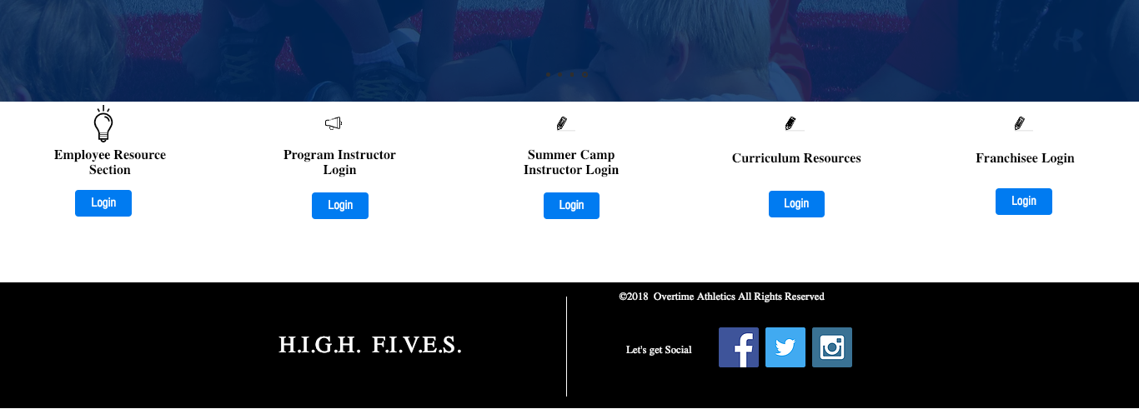

We also have a built-in Online Support Center for our Franchisee’s



Under the locations tab, each territory will have their own page – The franchisee will not have to update or manage their territory page but can select the information they want families to see.

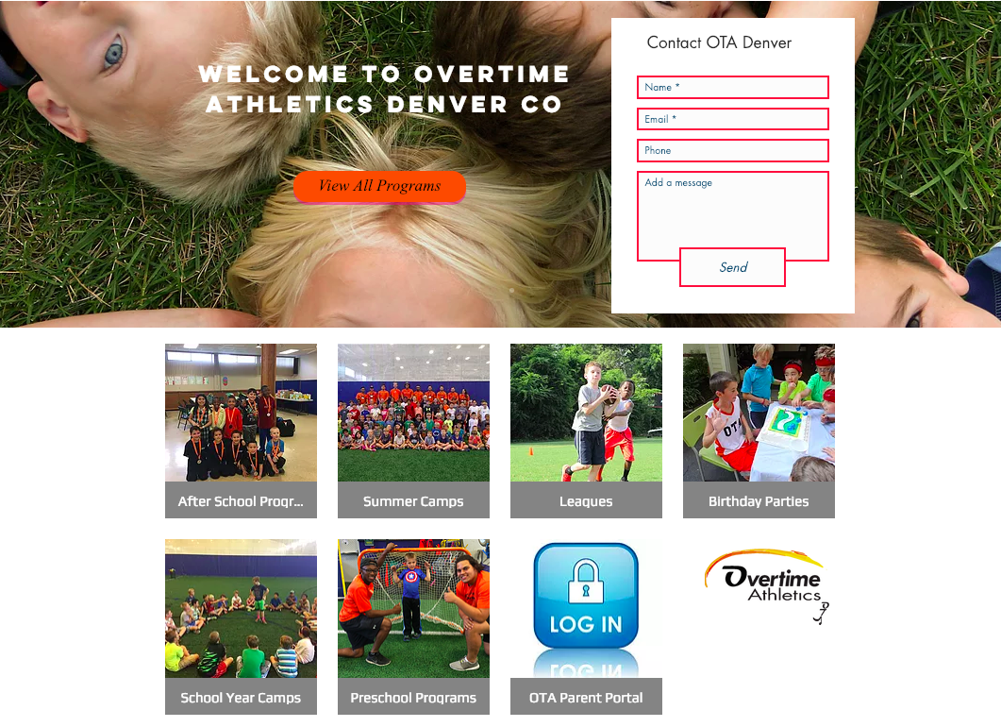

Families that want to register in a program would select from:

* After School Programs
* Summer Camps
* Leagues
* Birthday Parties
* School Year Camps
* PreSchool Camps
* OTA Parent Portal

When parents select one of the icons, it will take families to your territories Jumbula site that you will maintain.

Confirm contact information on OTA Website – Locations Tab: Completed -

Confirm Posted Picture: Completed -

Social Media Set-Up

Facebook Set-up (Required)

Instagram, Twitter, Youtube, SnapChat (Optional)

* Create a New Facebook Business Page
* Inside the Marketing Folder (Sharepoint) you will see the tab ‘logos’
  + Inside logos you will see a tab for Facebook
    - You can use any pictures you want

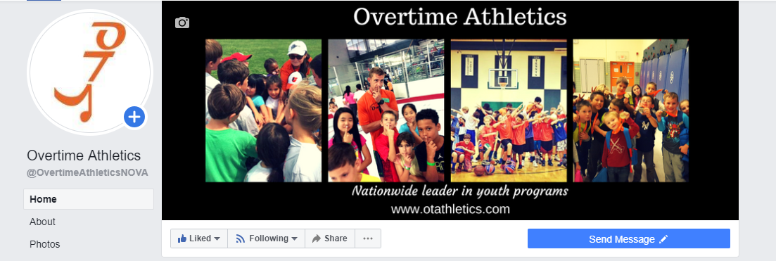

Set up your OTA Business Facebook Account. Please send Facebook ID number to Whelan: Whelan@otathletics.com

Send the Facebook ID Number (In About Section on Facebook): Completed -

Insurance Policy Requirements:

**GENERAL LIABILITY** – PROVIDES COVERAGE FOR BODILY INJURY AND PROPERTY DAMAGE.

* EX: CAMPER IS INJURED AND PARENTS FILE LAW SUIT AGAINST FRANCHISEE. THE LIABILITY COVERAGE
* PROVIDES DEFENSE COVERAGE (ATTORNEY’S FEES) AND PAYS ANY AWARDS.
* IN ADDITION, THE SCHOOLS, GYMS, AND LOCATIONS WHERE CAMPS TAKE PLACE WILL REQUIRE GENERAL LIABILITY COVERAGE AND MOST LIKELY BE ASKED TO BE NAMED ADDITIONAL INSURED.

**SEXUAL ABUSE & CHILD MOLESTATION** – PROVIDES DEFENSE (ATTORNEY’S FEES) AND PAYS FOR ANYAWARDS.

* EX. CAMPER CLAIMS A COUNSELOR/COACH TOUCHED THEM INAPPROPRIATELY OR MADE THEM FEEL UNCOMFORTABLE.
* IN OUR AGENCY’S EYES THIS IS A NECESSITY TO HAVE WHEN RISKS ARE DEALING WITH CHILDREN.
* IN ADDITION, WE HAVE SEEN THIS BE A REQUIREMENT FOR SOME CERTIFICATE HOLDERS.

**EXCESS LIABILITY** – PROVIDES COVERAGE OVER AND ABOVE THE UNDERLYING GENERAL LIABILITY COVERAGE.

* EX. CAMPER SUFFERS BODILY INJURY AND THE GENERAL LIABILITY LIMIT IS EXHAUSTED.
* THE EXCESS LIABILITY GOES OVER THE EXHAUSTED LIMIT.

**WORKERS COMPENSATION** – REQUIRED IN EVERY STATE. PROVIDES WAGES & MEDICAL BENEFITS FOR EMPLOYEES INJURED WHILE WORKING.

* EX. COUNSELOR BREAKS AN ARM WHILE WORKING. WORKERS COMPENSATION COVERAGE WILL PAY FOR MEDICAL COSTS STARTING AT DOLLAR ONE.
* WILL ALSO PROVIDE A PERCENTAGE OF THAT EMPLOYEE’S WAGE’S WHILE HE/SHE IS UNABLE TO WORK.
* THIS IS A REQUIREMENT ON MOST IF NOT ALL OF THE REQUESTS WE SEE FROM CERTIFICATE HOLDERS.

**ACCIDENT MEDICAL** – PROVIDES MEDICAL BENEFITS TO CAMPERS WHO ARE INJURED WHILE ATTENDING CAMP.

* PENDING THE POLICY LANGAUGE, MEDICAL PAYMENTS COVERAGE ON THE GENERAL LIABILITY COVERAGE OFTEN EXCLUDES MEDICAL PAYMENTS.

Insurance Coverage Details:

* Insurance
  + We require that your insurance must be in effect at all times:

**Policy Type:** Commercial Package

**Term:** 12 Months

**Policy Limits:** General Liability Aggregate Limit: $2,000,000

Products/Completed Operations Aggregate Limit: $2,000,000

Personal and Advertising Injury Limit $2,000,000

Each Occurrence Limit $1,000,000

Sexual or Physical Abuse or Molestation Vicarious Liability

Aggregate Limit $200,000

Each Abuse Conduct Limit $100,000

Medical Expense Limit (Any One Person) $5,000

**Workers’ Compensation:** Statutory (with All States Broad Form)

* + All policies of insurance must require a thirty-day notice of cancellation to us including notice of non-payment of premiums.
  + You must name us as an additional insured and forward Certificates of Insurance to us within seven days of procuring the insurance.
  + If you rent space and your lease requires coverage at an amount different from that listed above, you must obtain coverage in whichever amount is higher.
  + The insurance must be in effect before the franchise begins operation and continue in effect, uninterrupted.

CONTACT: Patrick B. McKiernan

Certified Insurance Counselor (CIC)

Commercial Lines Account Representative

Abercrombie Burns McKiernan & Co., Ins., Inc.

(203) 655-7468

[pmckiernan@abmck.com](mailto:pmckiernan@abmck.com)

Set up introductory call with Insurance Broker to establish a line of communication and review the process for securing coverage

Applications: Completed -

Bind Coverage: Completed -

Background Check and Clearance Platform

Clearance Reports:

* To be clear, a background check must be completed on every instructor that is hired prior to sending them to a program
* Clearance Reports need to be accessible or should be printed out and included as a hardcopy in the Instructor’s Employment File
* You should be able to access them at any time on the Protect Youth Sports Platform

**Clearance Company: Protect Youth Sports (www.protectyouthsports.com)**

* 1. Call 877.319.5587 to set up your account.
  2. You will let them know the state you are in and they will connect you with the correct representative.
  3. Typically, the cost of a background check using their service is between $9-$15 per employee.
  4. You have the option of passing this expense on to your New Hire.
  5. Once your account is set up, you will be able to instruct your New Hire’s to log on themselves to register for their background check to be completed.
  6. You will want to become familiar with using this platform to sort instructors, monitor status of clearance reports, print reports for filing and record keeping, etc.
  7. NOTE – you will complete your Child Protection Course through Protect Youth Sports

Create Background Check Account: Completed -